**LockedMe.com  
(Virtual key for your repositories)**

**Developed by: Dhanala Tarakeswara Rao**

**What is LockedMe.com:**

It is virtual repository which can store files in a designated path or folder which is set by the user.

**Features:**

The application has mainly 3 features in it, which are mentioned below.  
  
1. Search a file: The user can search for an existing file.

2. Add a file: With this option, user can add a new file to your folder.

3. Delete a file: Using this option, user can delete an existing file.

**Uses:**   
* The main usage is, that you can store any number of files.

* User can easily navigate for a file using the “search” option.

* The file cannot be traced unless the correct name is provided.

* User can delete the unwanted files using delete option.

The application also has these options, “main menu, sorting of files in ascending order and exit”.

# Sprint 1:

* Design Flow chart of the program
* Add one feature: Display Files of a folder on ascending order
* Add the First Feature code in GitHub

**Sprint 2:**

Second Feature: User Interaction Mode

* + Create File Method
  + Search File Method
  + Delete File Method
  + Option For main Menu 2: Exit option

**GitHub link:**

**Flow chart of the process:**

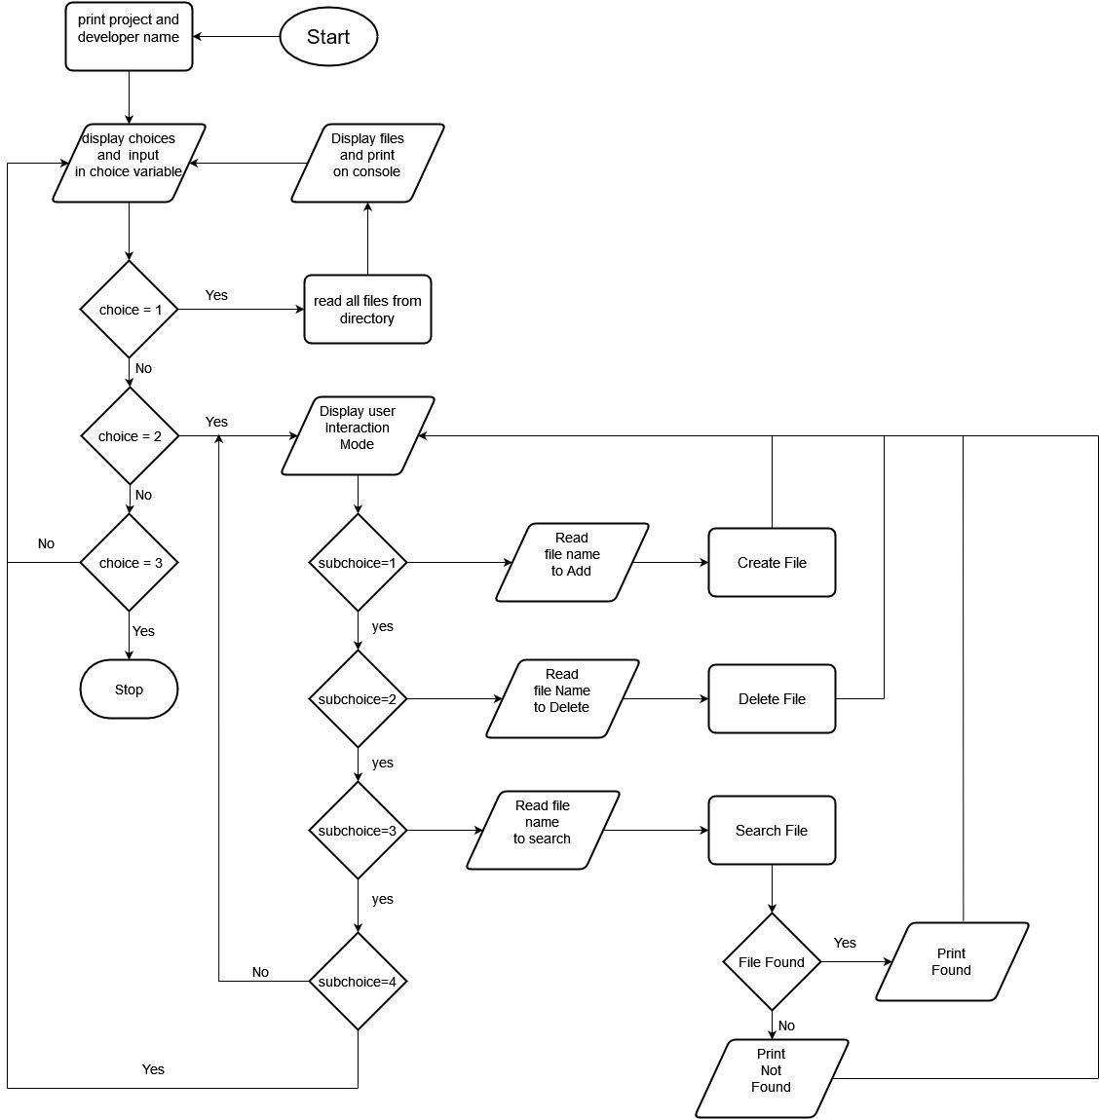

**Process flow:**

Start

1. Print options to list, manage files and exit
2. If choice is 1
   * Read all files in the directory
   * Sort all the files in ascending order using Arrays. Sort
   * Print all the files
3. If the choice is 2
   * Print Options to add, search and delete files
   * If the sub choice is 1
4. Accept file name from the user
5. Create a new file with that name
   * If the sub choice is 2
6. Accept file name from the user
7. Delete the file with that name
   * If the sub choice is 3
8. Accept file name from the user
9. Search for file with that name
10. If file found print file name
11. Else print Not found
    * If the sub choice is 4 go to 2
12. If the choice is 3 go to 7
13. Stop

**\*\*\*\*\*\*\*\*\*\*\*\*\*\*\*\*\*\*\*\*\*\*\*\*\*\*\*Thank you for choosing LockedMe.com\*\*\*\*\*\*\*\*\*\*\*\*\*\*\*\*\*\*\*\*\*\***